SAUDI BASIC SCIENCE – Saudi Basic Science Consortium Grant (BSRCG)
Standard Full-Proposal
 | Structure of the Proposal | 
- The proposal contains two parts:
- Part A of the proposal captures the general information regarding the project and participants.
- Part B of the proposal is the narrative part that includes sections covering the evaluation criteria.

Section | Title | Page No
Part A: Application Form
1 | Project Information
2 | Team Structure
3 | Budget Breakdown and Duration
4 | Modification from Pre-Proposal
Part B: Technical Description
 | General instructions for filling the form: | 
- The structure of this template must be followed when preparing your proposal. It has been designed to ensure that the important aspects of your planned work are presented in a way that will enable the experts to make an effective assessment against the evaluation criteria
- The proposal template is downloadable from the portal. It needs to be filled, saved as a PDF and uploaded to the portal.
- Proposal page limit: 50 pages maximum (for technical part B)
- Fonts and font size: Arial, Courier New or Palatino: 10 points or larger; Times New Roman, Calibri: 11 points or larger.
- Margins: At least 1.5cm on all sides. Single line space or larger.
- Footer: Include proposal title (smaller font size can be used) and page number (outside right corner)
- References: Use numbered referencing styles which are characterized by references indicated in-text by superscript numbers, or numbers in brackets.
- Further details regarding the grant: max ticket size, duration, eligibility and award criteria, please refer to the call for proposal document

PART A: APPLICATION FORM
 | General Information | 

Grant Program | Saudi Basic Science
Grant | Basic Science Research Consortium Grant
National Priority
National Mission
Research Focus
RDI Domain
Key Technology Used
Proposal Title | Max 200 characters (with spaces). It must be understandable for non-specialists in your field.
Keywords | Enter any words you think give extra detail of the scope of your proposal (max 200 characters with spaces)

Abstract
Maximum words: | 400

Has this proposal (or a very similar one) been submitted in the past 2 years in response to a call for proposals under any RDIA initiative? * | ○ | Yes | ○ | No
Please give the proposal reference or contract number

Declarations
- We declare to have the explicit consent of all applicants on their participation and on the content of this proposal. | □
- We confirm that the information contained in this proposal is correct and complete and that none of the project activities have started before the proposal was submitted (unless explicitly authorized in the call conditions) | □
- We declare:  - To be fully compliant with the eligibility criteria set out in the call  - To have the financial and operational capacity to carry out the proposed project | □
- We acknowledge that all communication will be made through the official portal, unless directly specified otherwise | □
- We have read, understood and accepted the Terms of Use that set out the conditions of use of the Portal and outline the responsibilities, limitations, and guidelines for accessing and using its services. | □
- We declare that the proposal has an exclusive focus on civil applications. If the project involves dual-use items or other items for which authorization is required, we confirm that we will comply with the applicable regulatory frameworks (e.g. obtain export/import licenses before these items are used) | □
- We declare that this proposal does not contain any investigators included on the basis of personal or reciprocal arrangements, and that the list of Principal Investigators and Co-Principal Investigators is formed based solely on their ability to contribute meaningfully to the project. | □
The coordinator is only responsible for the information relating to their own organization. Each applicant remains responsible for the information declared for their organization
False statements or incorrect information may lead to disqualification of the applicant and further legal action

 | Team Structure | 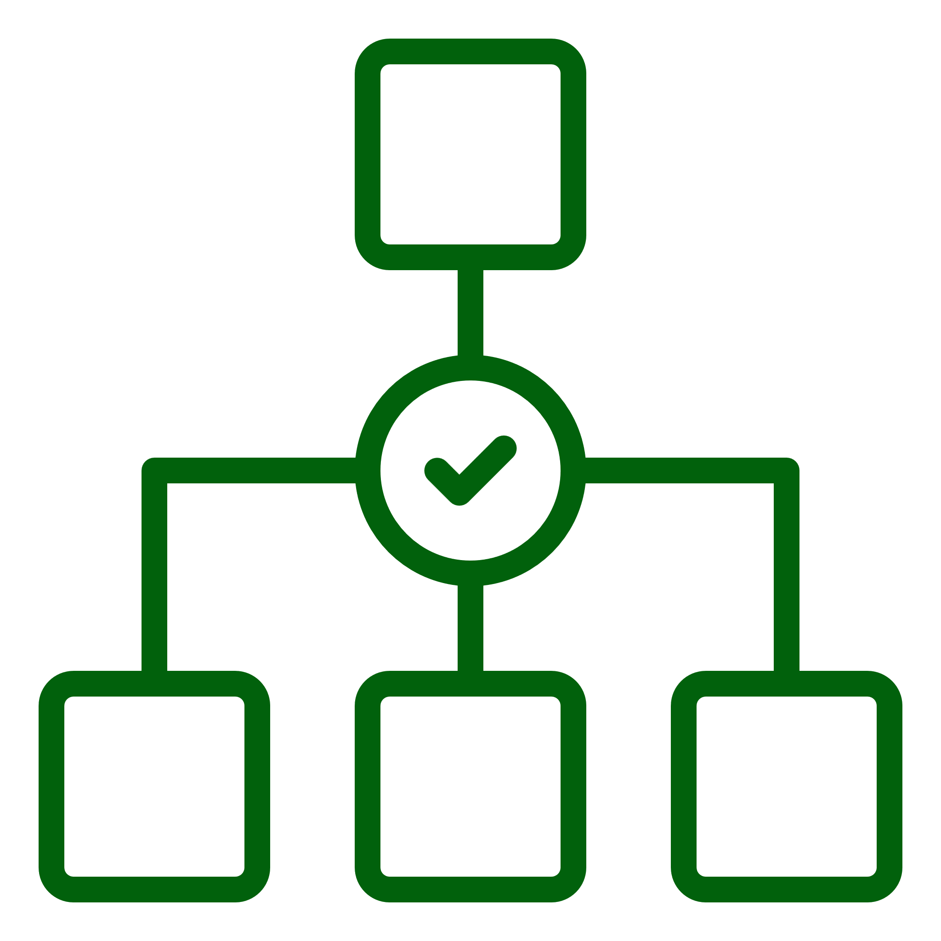

List of Participating Organizations and Potential Partners (for Consortium)
# | Organization Name | Role | Location | Beneficiary Type | Country | Brief Description | Website | Status
1
2
3
4

List and Role of Researchers in the Project
# | Title | First Name | Last Name | Gender | Nationality | Organization | Email | Position | Qualification | Role Category | Role
1
2
3
4
Please append CVs of all team members at the end of the proposal

Leading Organization Data
Lead Entity | Legal Name
Short Name:
Address:
Street:
Governate:
Postcode:
Country:
Webpage:
Specific Legal Statuses (Yes/No)
- Research Institute..................................................
- University ............................................................
- SME (Small Medium Sized Enterprise)...............................................................
- Corporate ………............................
Description of the Organization / Specialization, etc.

Point of Contact (POC) Details
Title |  |  | Gender |  | ○ |  | Female | ○ | Male
First Name |  |  | Last Name
E-Mail
Position in Org. | Please indicate the position of the person.
Department | Name of the department/institute carrying out the work.
Street | Please enter street name and number.
Governate | Please enter the name of the governate. |  | Post code |  |  | Area code.
Country | Please select a country
Website | Please enter website
Phone | +xxx xxxxxxxxx | Phone 2 |  | +xxx xxxxxxxxx

List of up to 5 publications, widely-used datasets, software, goods, services, or any other achievements relevant to the proposal
# | Type of Achievement | Short Description
1
2
3
4
5

List of up to 5 most relevant previous projects or activities related to the proposal
# | Name of Project/ Activity | Short Description
1
2
3
4
5

 |  | Budget Breakdown & Duration |  | 
Estimated Budget in SAR |  |  | 00
Total duration required for the completion of the project (in months) |  |  | 00
Total in years |  |  | 00

Summary of Budget Category Costs Proposed per Organization
Organization Name | Role | Beneficiary Type | Total Cost / Organization | Percentage | Funding Rate | RDIA Contribution / Organization | % of total Costs | Justifications*

Summary of Budget Category Costs Proposed – Lead Organization
Organization Name
Beneficiary Type
Funding Rate

Please fill and submit the budget sheet in excel format in addition to the table below
Category | Year 1 | Year 2 | Year 3 | Year 4 | Year 5 | Total Costs by Category | % of Total Costs | Justification*
a. Manpower cost
b. Equipment cost
c. Travel cost
d. Other Operating cost
e. Indirect cost
f. RDI Unit Overhead
Total project cost
RDIA contribution

Summary of Budget Category Costs Proposed – Consortium Partner #
Organization Name
Beneficiary Type
Funding Rate

Please fill and submit the budget sheet in excel format in addition to the table below
Category | Year 1 | Year 2 | Year 3 | Year 4 | Year 5 | Total Costs by Category | % of Total Costs | Justification*
a. Manpower cost
b. Equipment cost
c. Travel cost
d. Other Operating cost
e. Indirect cost
f. RDI Unit Overhead
Total project cost
RDIA contribution

Modification from Pre-Proposal

Please indicate any changes in the full proposal when compared to pre-proposal and the reasons for the modification

Are there any substantial changes from pre-proposal? | Yes | No

Team / Partnership | List any substantial differences and indicate the reason
Budget | List any substantial differences and indicate the reason
Approach | List any substantial differences and indicate the reason

PART B- TECHNICAL DESCRIPTION
Table of content |  | Main evaluation criteria addressed
SHORT PROPOSAL
- EXECUTIVE SUMMARY
- RESEARCH NOVELTY AND POTENTIAL IMPACT
1 | PROBLEM STATEMENT AND LONG-TERM VISION | SCIENTIFIC AMBITION AND INTELLECTUAL MERIT
2 | NOVELTY AND STATE-OF-THE-ART
3 | OBJECTIVES AND METHODOLOGY
4 | CONTRIBUTION TO GRANT CALL FOCUS | POTENTIAL IMPACT
5 | DISSEMINATION AND EXPLOITATION STRATEGY
6 | BROADER IMPACT
- TEAM AND IMPLEMENTATION
7 | CONSORTIUM PARTNER DESCRIPTION | TEAM AND EXPERTISE
8 | PI AND CO-PI TRACK RECORD
9 | CONSORTIUM CAPABILITIES
10 | YOUNG TALENT CAREER DEVELOPMENT
11 | TEAM MANAGEMENT
12 | IMPLEMENTATION PLAN | PROJECT IMPLEMENTATION
13 | RISK ASSESSMENT
14 | IMPORTANCE OF RDIA FUNDING
15 | BUDGET REQUEST WITH JUSTIFICATION

Fill in the title of your proposal below.
TITLE OF THE PROPOSAL
- EXECUTIVE SUMMARY (approx. ~2 pages)

This section should provide a concise and compelling overview of the entire proposal.

Important elements to include:
- Clear articulation of the problem or opportunity.
- Proposed solution and its innovation/breakthrough potential.
- Target market and its size.
- Team's expertise and capabilities.
- TRL advancement plan.
- Importance of RDIA funding and expected impact.

- RESEARCH NOVELTY AND POTENTIAL IMPACT (approx. ~30 pages)

- Problem Statement and Long-Term Vision: (approx. ~7 pages)
- Clearly define the problem, opportunity, and/or hypothesis being addressed and its significance.
- Describe the underlying vision of the solution, technology, process, or other to which the project would contribute in the long-term.

- Novelty and State-of-the-Art: (approx. ~5 pages)
- Describe the relevant state-of-the-art or current understanding of the respective field and discuss the novelty and ambition of the proposed research with respect to it.
- Describe the potential contribution of the proposed research to the realization or advancement of the underlying vision.

- Objectives and Methodology: (approx. ~10 pages)
- Describe the objectives of the project, which should be clear, plausible, verifiable and realistically achievable within the duration of the project.
- Describe and explain the overall methodology including the concepts, models and assumptions that underpin the proposed work. Explain how this will enable delivery of the project’s objectives. Refer to any important challenges identified in the chosen methodology and the proposition to overcome them.

- Contribution to Focus of Grant Call: (approx. ~2-3 pages)
- Demonstrate how the project aligns with the RDIA call's objectives and priorities (research topics indicated).
- Explain how the project will contribute to the field and meet the call's expected outcomes and impacts.

- Dissemination and Exploitation Strategy (approx. ~2 pages)
- Describe the dissemination and communication measures planned, as well as the target group(s) addressed for raising awareness about the project’s outcomes.
- Describe the measures/steps needed for a plausible path to translate the results of the project into higher TRLs.

- Broader Impact: (approx. ~2 pages)
- Discuss the societal, economic, environmental, and climate impacts of the proposal.
- Explain whether and how the proposal contributes to developing technologies of strategic importance to KSA.

- TEAM AND IMPLEMENTATION (approx. ~20 pages)

- Consortium Partner Description : (approx. ~2 pages)
- This section should provide a clear and concise overview of the applicant organizations (consortium partners).
- It should highlight the organizations’ core mission and vision, key assets/resources available (e.g., offices, laboratories, production facilities), and relevant experience.

- PI and Co-PI Track Record: (approx. ~2 pages)
- Present the Principal Investigator's (PI) and co-PI’s relevant experience, qualifications, and past successes, particularly those demonstrating their leadership ability.
- Provide the same for any co-PIs suggested as part of the project team.

- Consortium Capabilities: (approx. ~2 pages)
- Explain the link between the lead organization and consortium partners and describe their roles in the project.
- Describe the expertise and capabilities of each consortium partner, how these capabilities are required and complementary to achieve project success, and the overall value addition through collaboration.

- Young Talent Career Development (approx. ~1 page)
  - Describe how young talent career development is reflected in the proposed project, project team, and project implementation.
  - Highlight the specific project aspects that allow for talent development, and how this will benefit the young talent in their development.
  - Ensure to reflect any career development in the project team, and any other relevant sections.

- Team Management: (approx. ~ 3 pages)
- Present the team, highlighting the track record of PIs, and other team members, showcasing available skills and experience.
- Identify missing skills and outline recruitment plans to address these gaps.
- Elaborate on the proposed plan to manage the team, role of team members and their expected contribution to project goals.

- Implementation Plan: (approx., ~ 10 pages)
- Present a brief overview of the work plan's structure, describing the logical sequence of activities and corresponding deliverables.
- Describe the infrastructure and equipment required to successfully complete the project, highlight resources the project team has already secured access to and outline the plan for gaining access to the missing ones.
- Provide a visual representation of the project timeline using a Gantt chart or similar tool / representation.
- Leverage tables such as the one below to submit list of deliverables and milestones.

Deliverable Number | Deliverable Name | Short Description | Type of Deliverable | Delivery date  (in months)

Instructions:
Deliverable numbers in order of delivery dates.

Types of deliverables
Use one of the following codes:
R: Document, report (excluding the periodic and final reports)
DEM: Demonstrator, pilot, prototype, plan designs
DEC: Websites, patent filing, press & media activity, videos, etc.
DATA: Data sets, microdata, etc.
DMP: Data management plan
ETHICS: Deliverables related to ethics issues.
SECURITY: Deliverables related to security issues
OTHER: Software, technical diagram, algorithms, models, etc.

Delivery date
Measured in months from the project start date (month 1)

Milestone Number | Milestone Name | Due Date (in months) | Means of verification and link to the objectives of the project

Due date
Measured in months from the project start date (month 1)

Means of verification
Show how it will be confirmed that the milestone has been attained. Refer to indicators if appropriate. For example: field survey complete and data quality validated. Please also indicate how the milestone will contribute to achieving the objective of the project (including achievement of a specific TRL level).

- Risk Assessment: (approx. ~2 pages)
- Describe any critical risks relating to project implementation that the stated project's objectives may not be achieved.
- Outline the likelihood of these risks occurring, their potential effects, and the planned mitigation methods.
- Leverage the below table to summarize foreseen risks.

Description of Risk | Likelihood of occurring (Low/ Medium/ High) | Impact on project, if occurs | Severity of impact  (Low/ Medium/ High) | Risk Mitigation Measure

- Importance of RDIA Funding (approx. ~1-2 pages)
- Explain why RDIA funding is required and critical to support the successful execution of the project.

- Budget Justification (approx. ~2 pages)
- Provide the reasoning behind total project cost and highlight significant cost items.
- Explain if there is any deviation from industry standards.

- Any Additional Information (optional)

Appendix - Program Deliverables

# | Deliverable Category | Deliverable Type | Description | Quantity
1 | Publication | Publication in High-Impact Journal | Submit and have accepted one full-length research paper in a top-100 journal by 2024 Impact Factor (e.g. Nature, Science, Cell).
2 | Publication | Publication in Q1 Journal Articles | Submit and have accepted original research articles in Q1 journals (Scimago SJR).
3 | Publication | Publication in Q2 Journal Articles | Submit and have accepted one article in a Q2 journal
4 | Reports | Case Study / Case Report | In-depth analysis of a single case in context (e.g., patient case, teaching strategy, etc.).
5 | Reports | Clinical Trial Report | Describes the methodology, design, and outcomes of a clinical trial following standard reporting formats (e.g., CONSORT).
6 | Reports | Field Report / Field Study | Based on field observations and data collection, often in natural sciences, anthropology, or archaeology.
7 | Data | Data Sets | Structured datasets used or produced during the project (e.g., summary tables, processed variables).
8 | Data | Microdata | Anonymized, raw individual-level data records with appropriate documentation (e.g., codebook).
9 | Data | Data Management Plan | Written plan detailing data collection, storage, sharing, preservation, and reuse policies.
10 | ETHICS | Data Privacy Impact Assessment | Report assessing risks and safeguards for handling sensitive or personal data in the research.
11 | ETHICS | IRB Approval | Institutional Review Board (or equivalent ethics committee) approval for human subject research.
12 | ETHICS | Informed Consent Pack | Templates and completed forms used to obtain informed consent from study participants.
13 | Others | Algorithms, Technical Diagram, Software | Documented algorithms, System architecture diagrams, flowcharts, or workflow representations of methods or data pipelines, Software scripts, tools, or applications

