SAUDI APPLIED RESEARCH & TECHNOLOGY – Baseload Applied Grant (BAG)
Standard Full-Proposal
 | Structure of the Proposal | 
- The proposal contains two parts:
- Part A of the proposal captures the general information regarding the project and participants.
- Part B of the proposal is the narrative part that includes sections covering the evaluation criteria.

Section | Title | Page No
Part A: Application Form
1 | Project Information
2 | Team Structure
3 | Budget Breakdown and Duration
4 | Modification from Pre-Proposal
Part B: Technical Description
 | General instructions for filling the form: | 
- The structure of this template must be followed when preparing your proposal. It has been designed to ensure that the important aspects of your planned work are presented in a way that will enable the experts to make an effective assessment against the evaluation criteria
- The proposal template is downloadable from the portal. It needs to be filled, saved as a PDF and uploaded to the portal.
- Proposal page limit: 50 pages maximum (for technical part B)
- Fonts and font size: Arial, Courier New or Palatino: 10 points or larger; Times New Roman, Calibri: 11 points or larger.
- Margins: At least 1.5cm on all sides. Single line space or larger.
- Footer: Include proposal title (smaller font size can be used) and page number (outside right corner)
- References: Use numbered referencing styles which is characterized by references indicated in-text by superscript numbers, or numbers in brackets.
- Further details regarding the grant: max ticket size, duration, eligibility and award criteria, please refer to the call for proposal document

PART A: APPLICATION FORM
 | General Information | 

Grant Program | Saudi Applied Research & Technology
Grant | Baseload Applied Grant
National Priority
National Mission
Research Focus
RDI Domain
Key Technology Used
Proposal Title | Max 200 characters (with spaces). It must be understandable for non-specialists in your field.
Keywords | Enter any words you think give extra detail of the scope of your proposal (max 200 characters with spaces)

Abstract
Maximum words: | 400

Has this proposal (or a very similar one) been submitted in the past 2 years in response to a call for proposals under any RDIA initiative? * | ○ | Yes | ○ | No
Please give the proposal reference or contract number

Declarations
- We declare to have the explicit consent of all applicants on their participation and on the content of this proposal. | □
- We confirm that the information contained in this proposal is correct and complete and that none of the project activities have started before the proposal was submitted (unless explicitly authorized in the call conditions) | □
- We declare:  - To be fully compliant with the eligibility criteria set out in the call  - To have the financial and operational capacity to carry out the proposed project | □
- We acknowledge that all communication will be made through the official portal, unless directly specified otherwise | □
- We have read, understood and accepted the Terms of Use that set out the conditions of use of the Portal and outline the responsibilities, limitations, and guidelines for accessing and using its services. | □
- We declare that the proposal has an exclusive focus on civil applications. If the project involves dual-use items or other items for which authorization is required, we confirm that we will comply with the applicable regulatory frameworks (e.g. obtain export/import licenses before these items are used) | □
- We declare that this proposal does not contain any investigators included on the basis of personal or reciprocal arrangements, and that the list of Principal Investigators and Co-Principal Investigators is formed based solely on their ability to contribute meaningfully to the project. | □
The coordinator is only responsible for the information relating to their own organization. Each applicant remains responsible for the information declared for their organization
False statements or incorrect information may lead to disqualification of the applicant and further legal action

 | Team Structure | 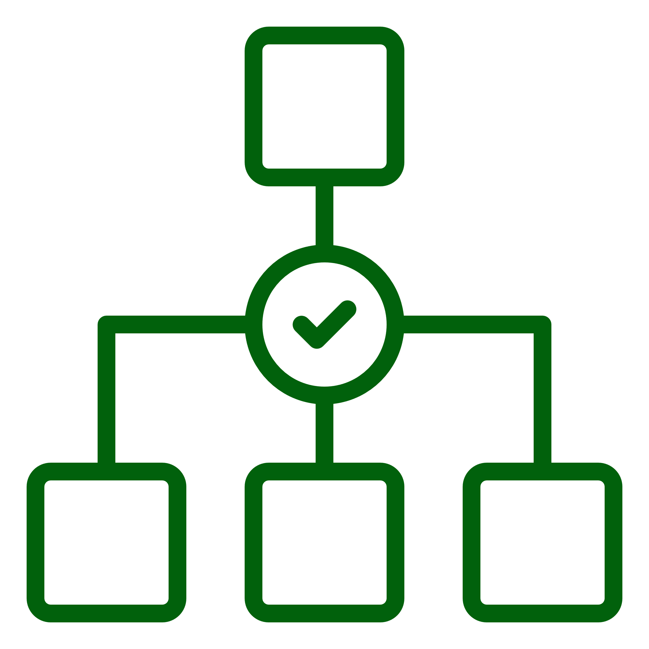

List of Participating Organizations and Potential Partners
# | Organization Name | Role | Location | Beneficiary Type | Country | Brief Description | Website | Status
1
2
3
4

List and Role of Researchers in the Project
# | Title | First Name | Last Name | Gender | Nationality | Organization | Email | Position | Qualification | Role Category | Role
1
2
3
4
Please append CVs of all team members at the end of the proposal

Leading Organization Data
Lead Entity | Legal Name
Short Name:
Address:
Street:
Governate:
Postcode:
Country:
Webpage:
Specific Legal Statuses (Yes/No)
- Research Institute..................................................
- University ............................................................
- SME (Small Medium Sized Enterprise)...............................................................
- Corporate ………............................
Description of the Organization / Specialization, etc.

Point of Contact (POC) Details
Title |  |  | Gender |  | ○ |  | Female | ○ | Male
First Name |  |  | Last Name
E-Mail
Position in Org. | Please indicate the position of the person.
Department | Name of the department/institute carrying out the work.
Street | Please enter street name and number.
Governate | Please enter the name of the governate. |  | Post code |  |  | Area code.
Country | Please select a country
Website | Please enter website
Phone | +xxx xxxxxxxxx | Phone 2 |  | +xxx xxxxxxxxx

List of up to 5 publications, widely-used datasets, software, goods, services, or any other achievements relevant to the proposal
# | Type of Achievement | Short Description
1
2
3
4
5

List of up to 5 most relevant previous projects or activities related to the proposal
# | Name of Project/ Activity | Short Description
1
2
3
4
5

 | Budget Breakdown & Duration | 

Estimated Budget in SAR | 00
Total duration required for the completion of the project (in months) | 00
Total in years | 00

Summary of Budget Category Costs Proposed (Individual Grant)
Organization Name
Beneficiary Type
Funding Rate

*Please fill and submit the budget sheet in excel format in addition to the table below
Category | Year 1 | Year 2 | Year 3 | Year 4 | Year 5 | Total Costs by Category | % of Total Costs | Justification*
a. Manpower cost
b. Equipment cost
c. Travel cost
d. Other Operating cost
e. Indirect cost
f. RDI Unit Overhead
Total project cost
RDIA contribution

Modification from Pre-Proposal

Please indicate any changes in the full proposal when compared to pre-proposal and the reasons for the modification

Are there any substantial changes from pre-proposal? | Yes | No

Partnership | List any substantial differences and indicate the reason
Budget | List any substantial differences and indicate the reason
Approach | List any substantial differences and indicate the reason

PART B- TECHNICAL DESCRIPTION
Table of content |  | Main evaluation criteria addressed
SHORT PROPOSAL
- EXECUTIVE SUMMARY
- POTENTIAL FOR TECHNICAL BREAKTHROUGH
1 | PROBLEM STATEMENT | EXCELLENCE AND NOVELTY
2 | OBJECTIVES AND METHODOLOGY
3 | IP STRATEGY
4 | CONTRIBUTION TO GRANT CALL FOCUS | POTENTIAL IMPACT
5 | BROADER IMPACT
6 | MARKET INSIGHT AND POTENTIAL APPLICATION
7 | REALIZATION STRATEGY
- TEAM AND IMPLEMENTATION
8 | ORGANIZATION DESCRIPTION | TEAM AND EXPERTISE
9 | PI TRACK AND CO-PI TRACK RECORD
10 | TEAM MANAGEMENT
11 | IMPLEMENTATION PLAN | PROJECT IMPLEMENTATION
12 | RISK ASSESSMENT
13 | IMPORTANCE OF RDIA FUNDING
14 | BUDGET REQUEST WITH JUSTIFICATION

Fill in the title of your proposal below.
TITLE OF THE PROPOSAL
- EXECUTIVE SUMMARY (approx. ~2 pages)

This section should provide a concise and compelling overview of the entire proposal.

Important elements to include:
- Clear articulation of the problem or opportunity.
- Proposed solution and its innovation/breakthrough potential.
- Target market and its size.
- Team's expertise and capabilities.
- TRL advancement plan.
- Importance of RDIA funding and expected impact.

- POTENTIAL FOR TECHNICAL BREAKTHROUGH (approx. ~30 pages)

- Problem Statement: (approx. ~5 pages)
- Clearly define the problem being addressed and its significance.
- Provide evidence to support the problem statement (data, research, case studies).
- Explain why existing solutions are inadequate, how the proposed research aims to address the stated problem, and how the project outcomes will be innovative or distinctive with respect to the state-of-the art.

- Objectives and Methodology: (approx. ~10 pages)
- Describe the objectives of the project, which should be clear, plausible, verifiable and realistically achievable within the duration of the project.
- Describe and explain the overall methodology including the concepts, models and assumptions that underpin the proposed work. Explain how this will enable delivery of the project’s objectives and how the planned activities are focused on verification and validation of the innovative solution, method, or process under investigation. Refer to any important challenges identified in the chosen methodology and the proposition to overcome them.

- IP Strategy: (approx. ~1 page)
- Describe the proposed strategy for management of the intellectual property, foreseen protection measures, such as patents, design rights, copyrights, and any other.
- Discuss new intellectual property and data that is anticipated to be created as part of this effort, if any.
- Highlight any relevant scientific publications. Additionally, mention patents owned by others for which usage rights have been secured.

- Contribution to Focus of Grant Call: (approx. ~2-3 pages)
- Demonstrate how the project aligns with the RDIA call's objectives and priorities (research topics indicated).
- Explain how the project will contribute to the field and meet the call's expected outcomes and impacts.

- Broader Impact: (approx. ~2 pages)
- Discuss the societal, economic, environmental, and climate impacts of the proposal.
- Describe the organization’s potential for job creation over the next five years (including indirect jobs).
- Explain whether and how the proposal contributes to developing technologies of strategic importance to KSA.

- Market Insight and Potential Application: (approx. ~6 pages)
- Discuss how the proposed project could lead to a marketable product, service or process, if successful.
- Describe the potential “end-users”/target group of the expected innovation and potential size of the group or market.
- Demonstrate any additional supportive evidence of the market potential and/or dialogue with potential customers or end-users on the relevance of the proposed solution.

- Realization Strategy: (approx. ~4 pages)
- Describe the dissemination and communication measures planned, as well as the target group(s) addressed for raising awareness about the project’s outcomes.
- Describe the measures/steps needed for a plausible path to translate the results of the project into higher TRLs and, ultimately, commercialization.
- If applicable, describe the potential for the private sector or investor involvement in the exploitation of the results of the proposed project. Highlight any agreements or support secured from the abovementioned stakeholders in place.

- TEAM AND IMPLEMENTATION (approx. ~20 pages)

- Organization Description: (approx. ~2 pages)
- This section should provide a clear and concise overview of the applicant organization.
- It should highlight the organization's core mission and vision, key assets/resources available (e.g., offices, laboratories, production facilities), and relevant experience.

- PI Track and Co-PI Track Record: (approx. ~1 page)
- Present the Principal Investigator's (PI) relevant experience, qualifications, and past successes, particularly those demonstrating their leadership ability.
- Provide the same for any co-PIs suggested as part of the project team.

- Team Management: (approx. ~ 3 pages)
- Present the team, highlighting the track record of PIs, co-PIs (if applicable) and other team members, showcasing available skills and experience.
- Identify missing skills and outline recruitment plans to address these gaps.
- Elaborate on the proposed plan to manage the team, role of team members and their expected contribution to project goals.

- Implementation Plan: (approx., ~ 10 pages)
- Present a brief overview of the work plan's structure, describing the logical sequence of activities and corresponding deliverables.
- Describe the infrastructure and equipment required to successfully complete the project, highlight resources the project team has already secured access to and outline the plan for gaining access to the missing ones.
- Provide a visual representation of the project timeline using a Gantt chart or similar tool / representation.
- Leverage tables such as the one below to submit list of deliverables and milestones.

Deliverable Number | Deliverable Name | Short Description | Type of Deliverable | Delivery date  (in months)

Instructions:
Deliverable numbers in order of delivery dates.

Types of deliverables
Use one of the following codes:
R: Document, report (excluding the periodic and final reports)
DEM: Demonstrator, pilot, prototype, plan designs
DEC: Websites, patent filing, press & media activity, videos, etc.
DATA: Data sets, microdata, etc.
DMP: Data management plan
ETHICS: Deliverables related to ethics issues.
SECURITY: Deliverables related to security issues
OTHER: Software, technical diagram, algorithms, models, etc.

Delivery date
Measured in months from the project start date (month 1)

Milestone Number | Milestone Name | Due Date (in months) | Means of verification and link to the objectives of the project

Due date
Measured in months from the project start date (month 1)

Means of verification
Show how it will be confirmed that the milestone has been attained. Refer to indicators if appropriate. For example: an existing laboratory prototype; software released and validated by a user group; field survey complete and data quality validated. Please also indicate how the milestone will contribute to achieving the objective of the project (including achievement of a specific TRL level).

- Risk Assessment: (approx. ~2 pages)
- Describe financial risks and those related to technology, the market, competition, and the team that are not directly linked to project implementation.
- Outline the likelihood of these risks occurring, their potential effects, and your planned mitigation methods.
- Describe your strategy for obtaining regulatory approvals and ensuring compliance
- Leverage table such as below to summarize foreseen risks

Description of Risk | Likelihood of occurring (Low/ Medium/ High) | Impact on project, if occurs | Severity of impact  (Low/ Medium/ High) | Risk Mitigation Measure

- Importance of RDIA Funding (approx. ~2 pages)
- Explain why RDIA funding is required and critical to support the successful execution of the project.
- Explain how RDIA funding will enhance the innovation's development and business scalability.
- Outline the overall funding strategy for the future.
- Address any financing issues that could impact a project partner's ability to exploit the innovation.

- Budget Justification (approx. ~2 pages)
- Provide the reasoning behind total project cost and highlight significant cost items.
- Explain if there is any deviation from industry standards.

- Any Additional Information (optional)

Appendix - Program Deliverables

# | Deliverable Category | Deliverable Type | Description | Quantity
1 | Publication | Publication in High-Impact Journal | Submit and have accepted one full-length research paper in a top-100 journal by 2024 Impact Factor (e.g. Nature, Science, Cell).
2 | Publication | Publication in Q1 Journal Articles | Submit and have accepted original research articles in Q1 journals (Scimago SJR).
3 | Publication | Publication in Q2 Journal Article | Submit and have accepted articles in Q2 journals.
4 | DEMO | Demonstrator Prototype | Functional prototype showcasing project innovation.
5 | DEMO | Proof of Concept | Validated concept model demonstrating feasibility.
6 | Pilot Study | Field or Clinical Pilot Study | Pilot implementation with documented use-case, outcomes, and evaluation results.
7 | IP Licensing | Technology Licensing Agreement | Licensing agreements or negotiations for intellectual property developed in the project.
8 | Patent Filing | Patent Application Submission | Formal submission of patent applications based on project innovations.
9 | Software | Research Software / Tool | Developed tools, scripts, or applications published or deployed.
10 | Technical Diagram | System Architecture / Workflow Diagram | Technical drawings, blueprints, workflows, or system architecture.
11 | Videos | Project Video or Animation | Project-related videos, simulations, or digital animations used for dissemination or demonstration.
12 | Plan Designs | Engineering or Technical Designs | Engineering or architectural design plans contributing to implementation or scale-up.
13 | Product | Product Ready for Commercialization | Tangible or digital product ready for market introduction and commercialization (e.g. MVP, market-tested prototype).
14 | Others | Algorithms, Technical Diagram, Software | Documented algorithms, system diagrams, flowcharts, or software artifacts complementing the main output.

